

JK LAKSHMIPAT UNIVERSITY

DIGITAL CIRCUIT AND SYSTEMS  
(EE1120)

Activity 01

LOGIC GATES

Characterization

Date : 16th January 2023

Name : Bobby Sharma

AIM: Verify all the logic gates using tinker cad simulation.

APPARATUS REQUIRED: Tinker Cad Platform in your device.

THEORY: A logic gate is a simple switching circuit that determines whether an input pulse can pass through to the output in digital circuits. The following types of logic gates are commonly used:

* AND
* OR
* NOT
* NOR (Universal gate*)
* NAND (Universal gate*)
* XOR
* XNOR

(* A universal gate is a logic gate which can implement any Boolean function without the need to use any other type of logic gate.)

IC NUMBERS: IC numbers are used to identify the different types of logic gates. The number of gates per IC varies depending on the number of inputs per gate. The basic logic gates are the building blocks of more complex logic circuits.

* NOT GATE: The IC number of the NOT gate is 7404 Hex Inverter. The reason it is called Hex Inverter is because it has 6 NOT gate in its system and the output given by this gate is inversion to the input as shown in figure 1 and 2. The terminal 7 is attached to the ground and the terminal 14 is connected to the power supply. The representation is A = Complement of A

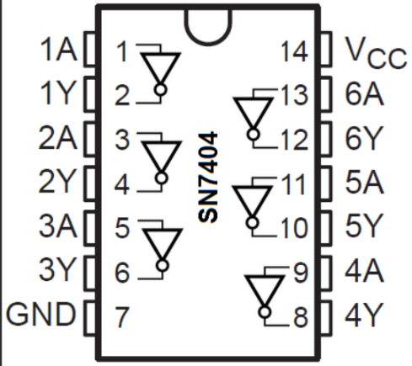

Figure 1 Figure 2

* AND GATE: The IC number of the AND gate is 7408. This gate gives the output by multiplying both the inputs. The representation is Y = A.B

The Quad AND gate are shown in figure 3 and 4. It has 4 AND gates. Later the terminal 7 is attached to the ground and the terminal 14 is connected to the power supply.

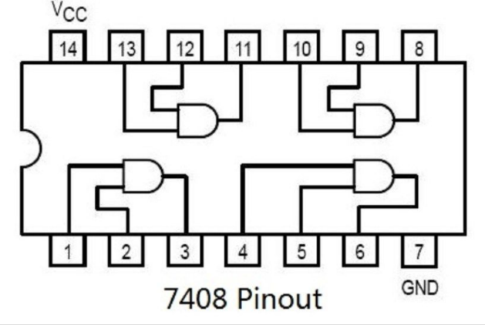 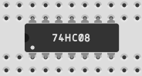

Figure 3 Figure 4

* OR GATE: The IC number of the OR gate is 7432. This gate gives the output by addition of both the inputs. The representation is Y = A+B

The Quad OR gate are shown in figure 5 and 6. It has 4 OR gates. Later the terminal 7 is attached to the ground and the terminal 14 is connected to the power supply.

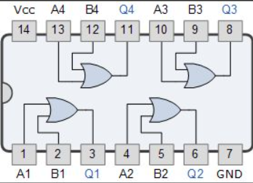 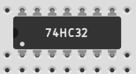

Figure 5 Figure 6

* X-OR GATE: The IC number of the X-OR gate is 7486. If the inputs of the X-OR gate have odd numbers of ones, then the output of the X-OR gate is high. If both inputs are the same value, then the output is low. The representation is Y = A+B (Exclusive or). It can also be represented by

Y = A.(Complement of B)+ (Complement of A).B

The Quad OR gate are shown in figure 7 and 8. It has 4 X - OR gates. Later the terminal 7 is attached to the ground and the terminal 14 is connected to the power supply.

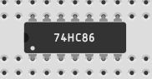 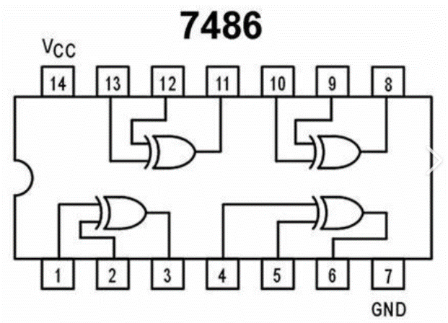

Figure 7 Figure 8

* X-NOR GATE: If the inputs of the X-NOR gate have an odd number of ones then the output is low. If both inputs of the X-NOR gate have the same, then the output is high. If there is no availability of an X-NOR gate, then there is a chance to implement the X-NOR gate by using basic and universal gates. The representation is Y = Complement of (X-OR GATE)

The X-NOR gate is shown in figure 9. It is combination of X-OR gate with the NOT gate . Later the terminal 7(of both gates) is attached to the ground and the terminal 14(of both gates) is connected to the power supply.

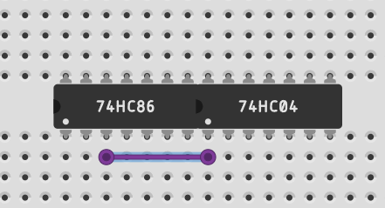

Figure 9

OBSERVATION: The observed outputs of all the basic gates are as follows:

* NOT GATE:

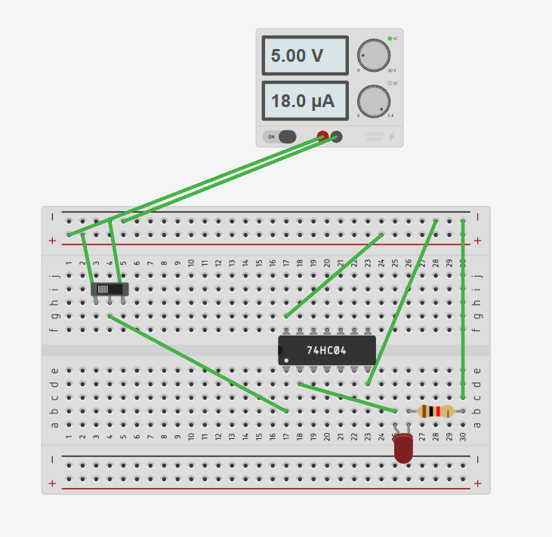 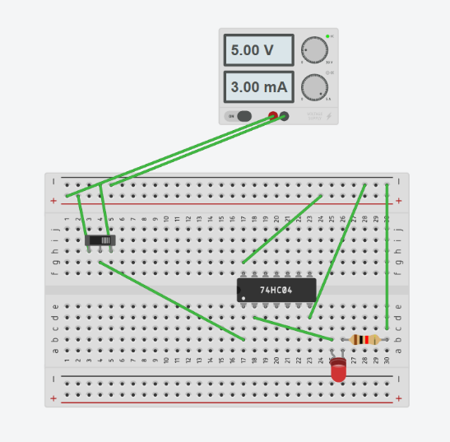

Figure 10 Figure 11

Figures 10 and 11 are showing the outputs when the slider switch is on and off. By observing this we can make the truth table of NOT gate which is shown in table 1.

|  |  |
| --- | --- |
| INPUT | OUTPUT |
| 1 | 0 |
| 0 | 1 |

Table 1

* AND GATE : 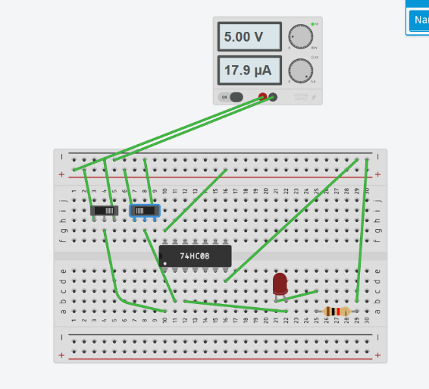 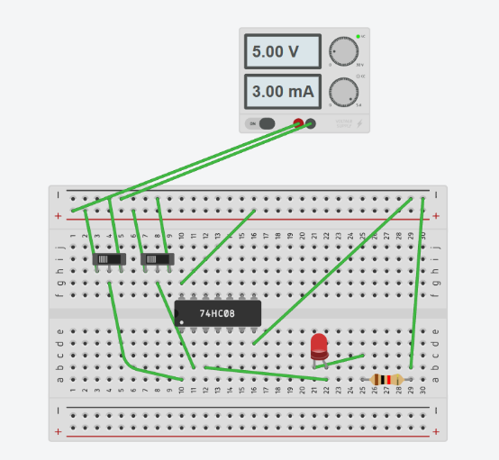

Figure 12 Figure 13

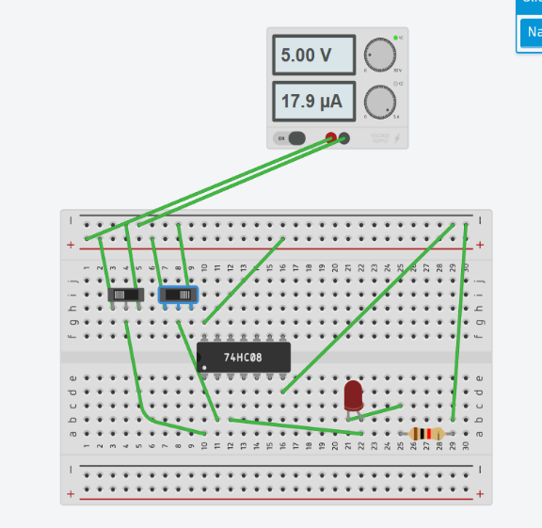 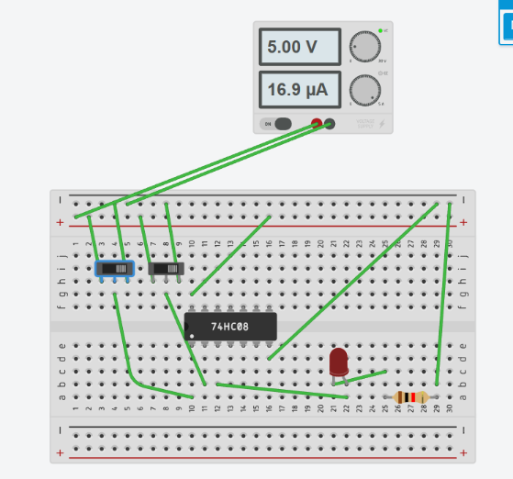

Figure 14 Figure 15

Figures 12,13,14 and 15 are showing the outputs when both the slider switch is on and off. By observing this we can make the truth table of AND gate which is shown in table 2.

|  |  |  |
| --- | --- | --- |
| A | B | Y = A.B |
| 0 | 0 | 0 |
| 0 | 1 | 0 |
| 1 | 0 | 0 |
| 1 | 1 | 1 |

Table 2

* OR GATE:

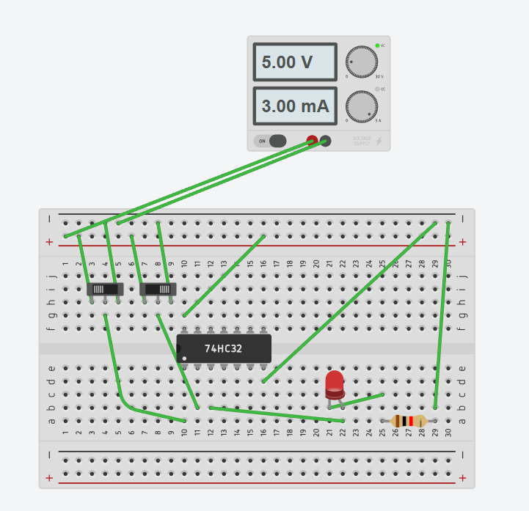 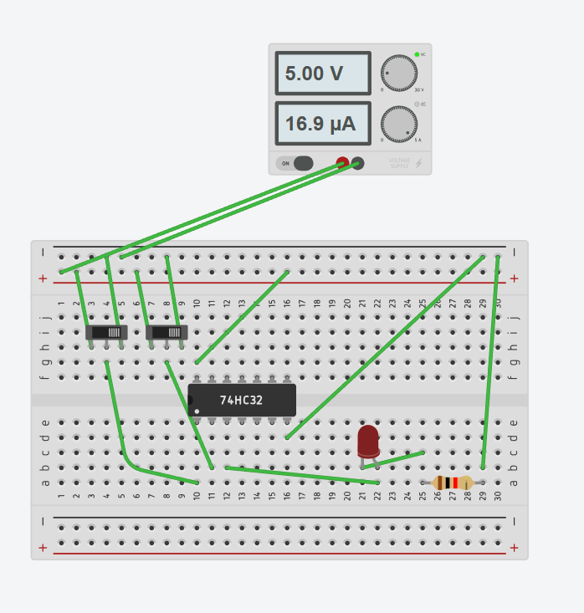

Figure 16 Figure 17

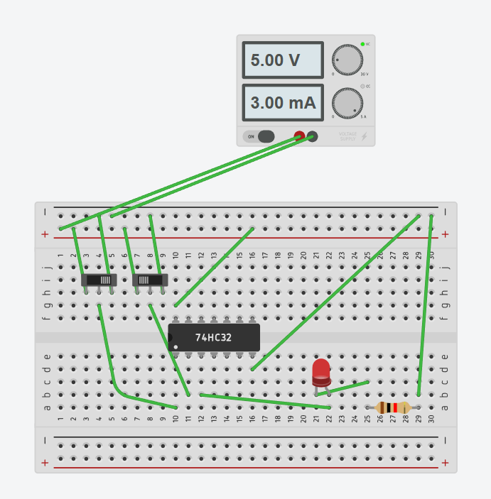 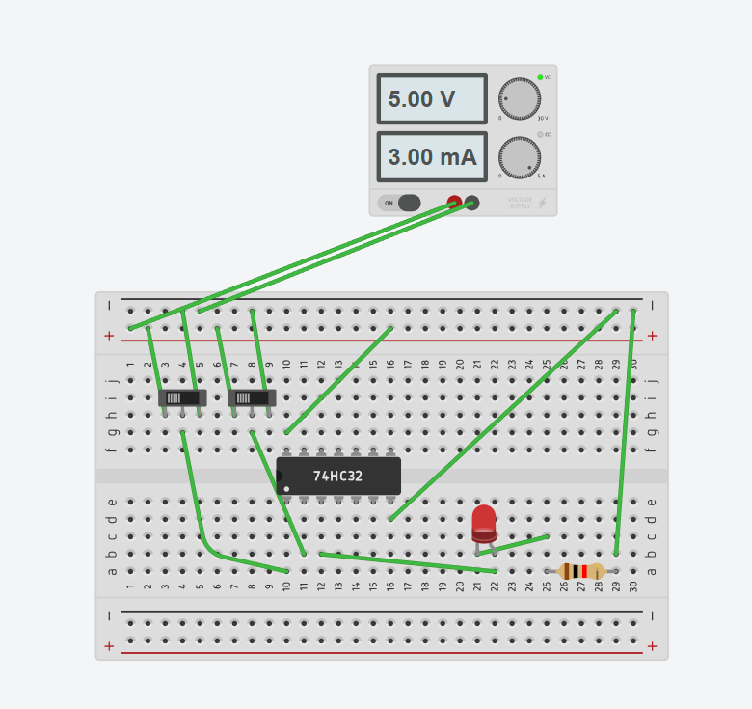

Figure 18 Figure 19

Figures 16,17,18 and 19 are showing the outputs when both the slider switch is on and off. By observing this we can make the truth table of OR gate which is shown in table 3.

|  |  |  |
| --- | --- | --- |
| A | B | Y = A+B |
| 0 | 0 | 0 |
| 0 | 1 | 1 |
| 1 | 0 | 1 |
| 1 | 1 | 1 |

Table 3

* X-OR GATE:

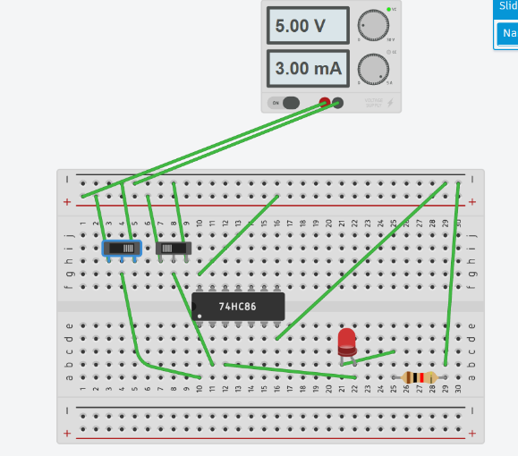 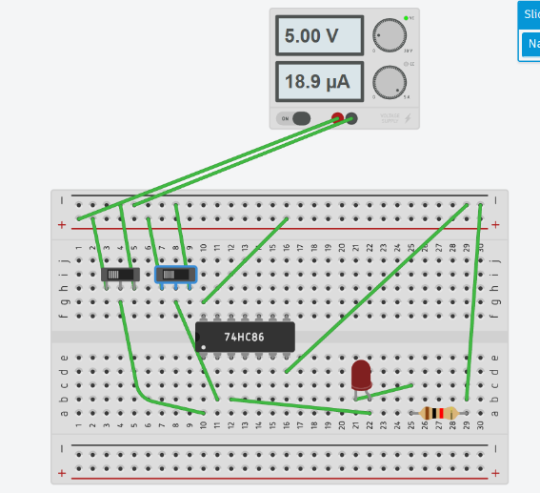

Figure 20 Figure 21

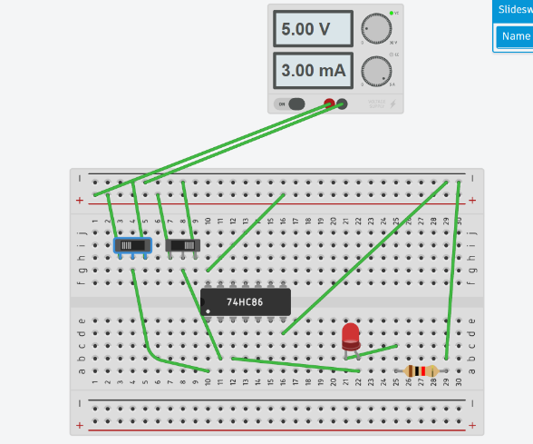 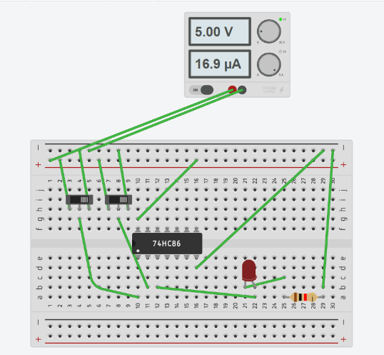

Figure 22 Figure 23

Figures 20,21,22 and 23 are showing the outputs when both the slider switch is on and off. By observing this we can make the truth table of OR gate which is shown in table 4.

|  |  |  |
| --- | --- | --- |
| A | B | Y = A+B (Exclusive or) |
| 0 | 0 | 0 |
| 0 | 1 | 1 |
| 1 | 0 | 1 |
| 1 | 1 | 0 |

Table 4

* X-NOR GATE:

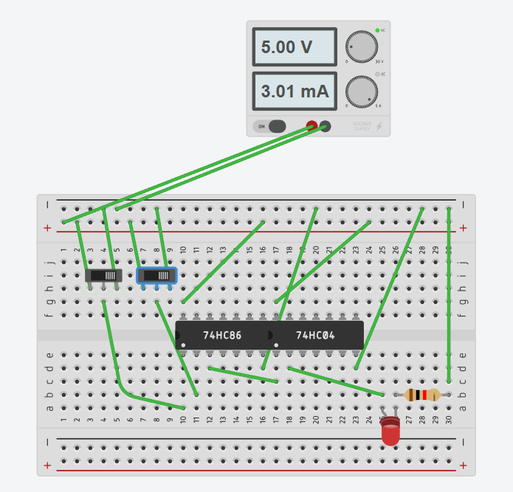 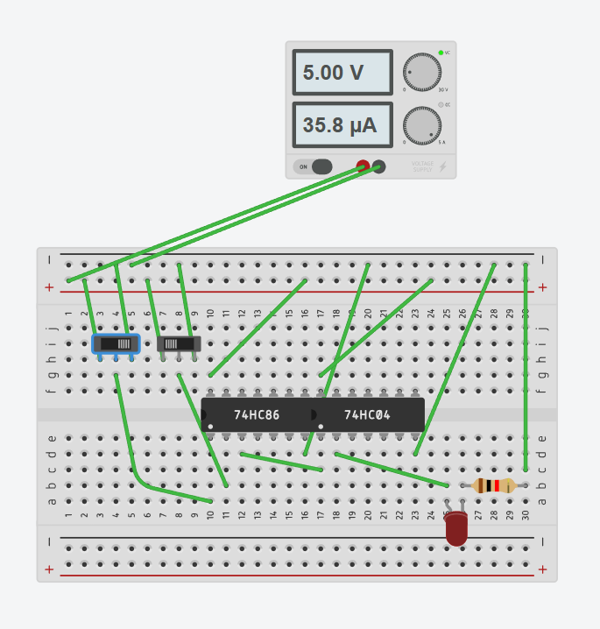

Figure 24 Figure 25

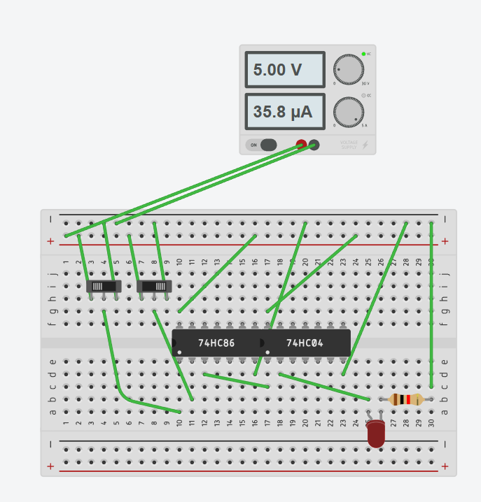 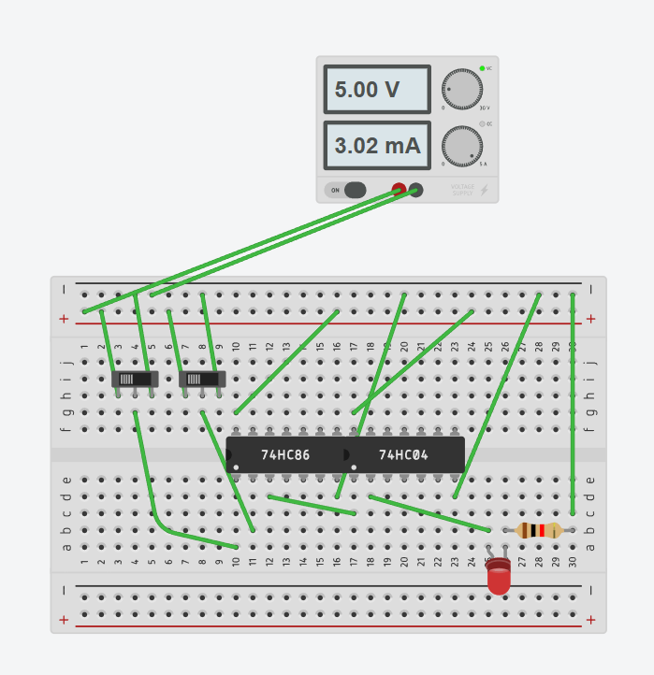

Figure 26 Figure 27

Figures 24,25,26 and 27 are showing the outputs when both the slider switch is on and off. By observing this we can make the truth table of OR gate which is shown in table 5.

|  |  |  |
| --- | --- | --- |
| A | B | Y = Complement of X-OR gate |
| 0 | 0 | 1 |
| 0 | 1 | 0 |
| 1 | 0 | 0 |
| 1 | 1 | 1 |

RESULT: We have concluded all the truth tables of all the basic logic gates from the tinker cad simulation.

APPLICATION IN DAILY LIFE:

Logic gates are fundamental building blocks of digital circuits and are used extensively in various electronic devices and systems. While we may not interact with logic gates directly in our daily lives, they play a crucial role in the functioning of numerous technologies and applications. Here are some examples of how logic gates are applied in daily life:

1. Computers and Smartphones:

* Logic gates are the foundation of digital circuits in computers and smartphones.
* They process and manipulate binary data, enabling the execution of complex tasks and running software applications.

1. Home Appliances:

* Modern home appliances often contain digital control systems that use logic gates.
* Microwaves, washing machines, and refrigerators may use logic gates to control various functions and operations.

1. Security Systems: Security systems, such as alarm systems and access control systems, utilize logic gates for processing signals from sensors and making decisions based on predefined conditions.